Little SPARK: Simple Play Adaptations to Reference for Kids

Sensory Twists
Description: | Image:
This item consists of six (three yellow and three red) 6.75" in diameter spiky PVC rings weighing 4 oz. each. Surface wash; air dry.  Purchasing Information  Demo Video | 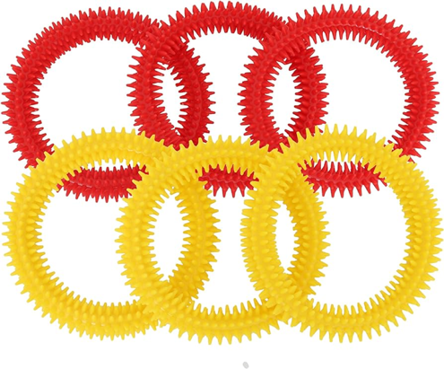

Who Might Benefit?
Those who are seek sensory input, are strengthening grasp, or benefit from touching/fidgeting to focus.
Why Use?
Explore the texture of the spiky ring, strengthen grip through twisting and pulling, develop fine motor skills, and fidget quietly to maintain focus.
Instructions for Use: | Adaptation Ideas:
Environmental Considerations  - Use in all settings and in group and one-on-one activities.  Positioning  - Use in any position; seated, standing, on the floor, etc.  Basic Play/Use Extended Play/Use  - Open ended exploration (ex. touch, twist, pull, squeeze). Ring toss or DIY Corn Hole.  Play/Use with Others  - Take turns catching rings or playing hide and seek. | Build It Up  - Wrap rings with fabric or foam for grasping surface.  Add Sensory Cues  - Store in sensory tub with other items.  Communication Supports  - Visual supports like communication cards and social narratives can help a child communicate their feelings.  Alternative Uses  - Use as timers or visual transitions (“When the bubbles settle it’s time to…”).  DIY Alternatives  - Inexpensive stretchy headbands at discount store, add sensory cues.

Words to Encourage Play/Use
Push  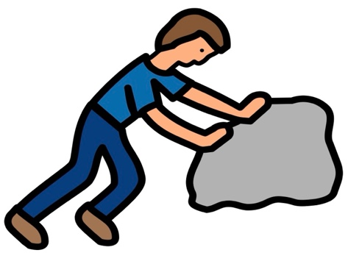 | Pull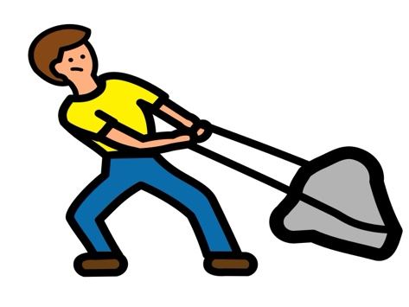 | Squeeze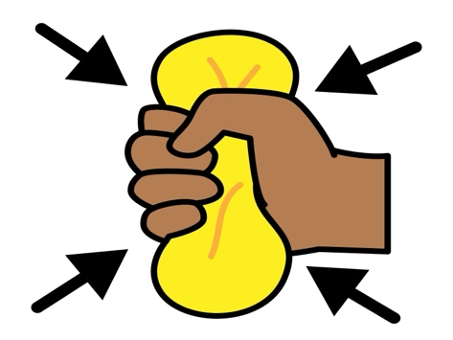
Twist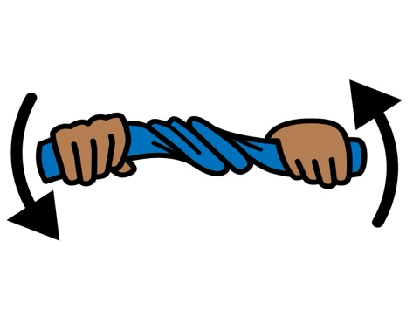 | Toss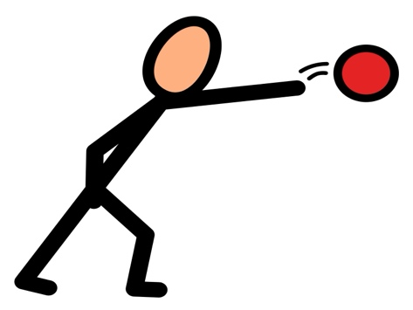 | Quiet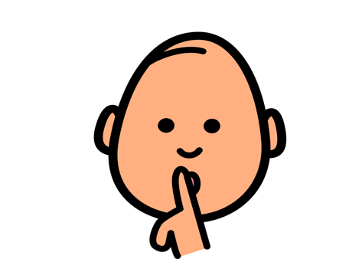
Calm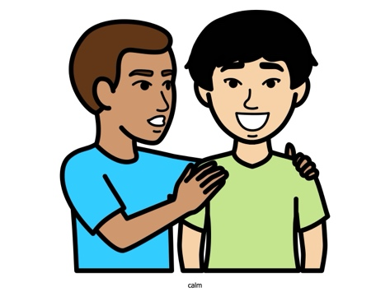 | Touch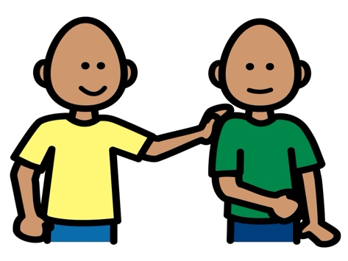 | Arms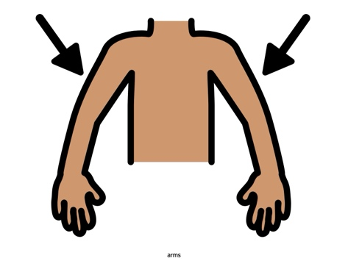
*”Adaptations” adapted from: Haugen’s Modes for Adapting Toys based on materials from the "Let's Play" Project at the University of Buffalo
PCS is a trademark of Tobii Dynavox, LLC. All rights reserved. Used with permission.

